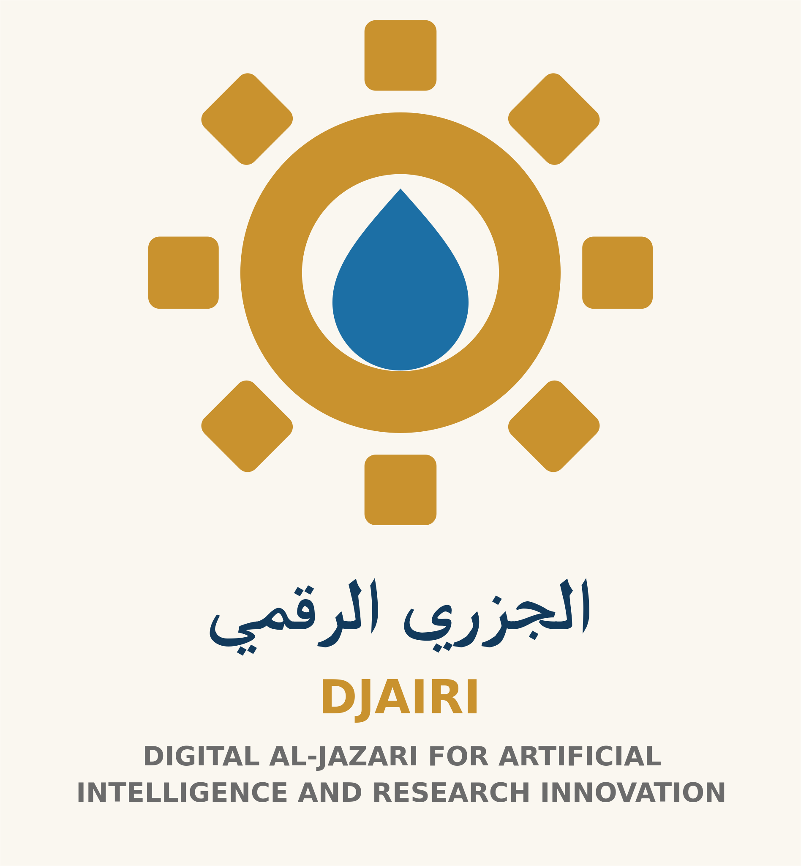

Five Steps to Check an AI Answer
Goal: turn an answer into claims you can check. Suggested time: 20 minutes. Use the answer and an appropriate primary source; a reliable book can replace online research.
1. Separate the claims. Mark names, dates, numbers and causal statements. Distinguish them from opinions and suggestions.
2. Request and open the source. A plausible title or link does not prove that a source exists. Find the actual document and check that it supports the specific claim.
3. Check context. Is the date relevant? Does the result apply to the country and audience? Has a small study been generalized to everyone?
4. Compare and correct. Use an independent source when useful. Record disagreement rather than selecting only supportive evidence. Label unsupported statements “unverified” and remove unwarranted certainty.
5. Decide how to use it. Share verified information with precise wording and its source. Obtain appropriate expert review for information affecting health, rights or finances.
Fictional example: an answer says “Every plant needs one litre of water daily.” It presents a universal quantity without context. Check species, soil and weather. A revised statement: “Water requirements vary by plant and conditions; consult relevant guidance before choosing an amount.” This is a verification exercise, not irrigation advice.
Worksheet: Claim: ______. Source: ______. What does it actually say? ______. Date and context: ______. Result: verified / disputed / unverified. Revised wording: ______.
Score 0–2 for each: identifying the claim, checking the source, reviewing context, stating uncertainty and correcting wording. Total: 10. This measures the exercise, not an accredited qualification.
Offline alternative: compare with a printed book or document and state its date and limits. Failure to find an online source does not itself prove a claim false; it may remain unresolved.
Application from our direction: if an answer claims Deir Al-Kahf photographs prove vegetation recovery, consult the project record. They show preliminary assessment and measurement. Revise to “a proposed restoration pathway subject to study,” separating a photograph from measured impact.
Human-Centered AI — DJAIRI. Version 1.1. Educational resource with human review; not field-tested with learners.

