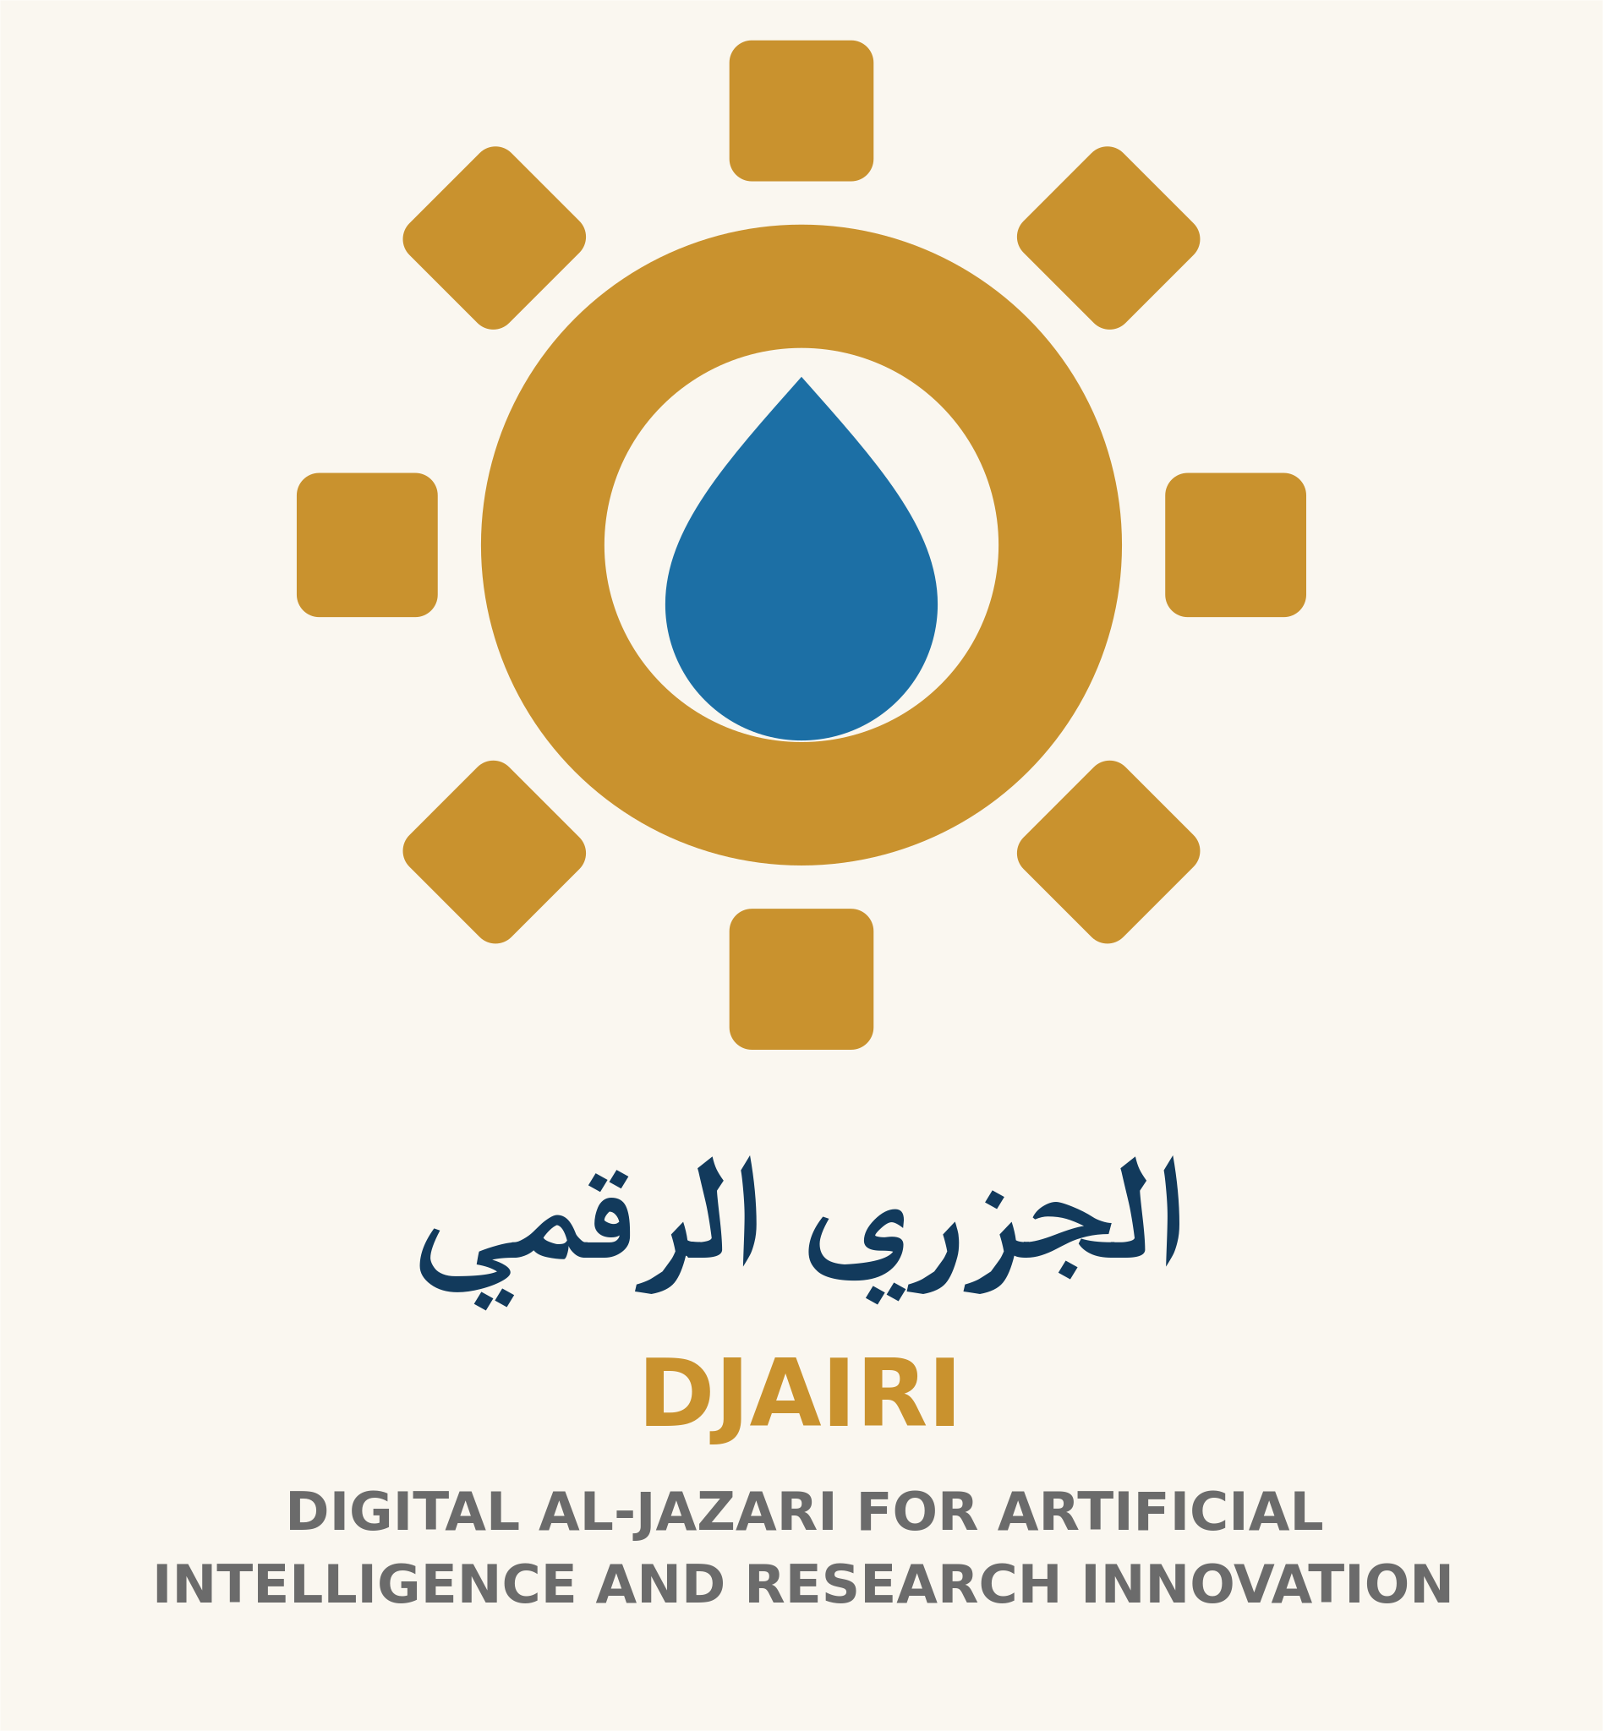

A Family Agreement for Using AI
Goal: a practical family discussion about using tools and protecting information. Suggested time: 20 minutes. This optional template is not a legal contract or a safety guarantee.
Start with a conversation: What do we want to learn or accomplish? What concerns us? Participation should suit each person’s age and abilities; it is not a test.
Agreement template — Purpose: We use tools for ______. Tools permitted after checking their terms and age requirements: ______. Adult responsible for supervision: ______. This agreement does not require a child to create an account.
Privacy: We do not upload names, photos, voices or documents concerning family members or others without an appropriate basis and required permission. We practise with fictional examples and never share passwords or precise locations.
Verification: We check important information and news before relying on it. We seek qualified help for health, financial or legal matters rather than treating a tool’s answer as a final decision.
Balance: We agree suitable times at ______ and protect time for activity, conversation and sleep. No single screen-time number is imposed on every age; review the family’s needs.
Help: If upsetting content or an unusual request appears, we stop and tell ______ without blame. We do not follow unknown links or send money based on an automated conversation.
Review: We revisit this agreement on ______ and adjust what no longer works. Anyone may request another discussion.
Fictional example: a family uses a tool to create questions about a public story. An adult reviews them before sharing with a child. They do not upload the child’s photo or named homework. Offline alternative: family members write questions themselves and exchange answers.
Success: everyone understands the purpose, what not to share and how to ask for help. Keep the completed template locally; do not submit children’s names or the agreement through a public form.
Weekly family choice: consider a general water-use question. Compare a tool’s suggestion with experience and a reliable source; do not assess drinking water using a model’s recipe. Children can ask and draw; adults review sources and safety.
Human-Centered AI — DJAIRI. Version 1.1. Educational resource with human review; not field-tested with learners.

