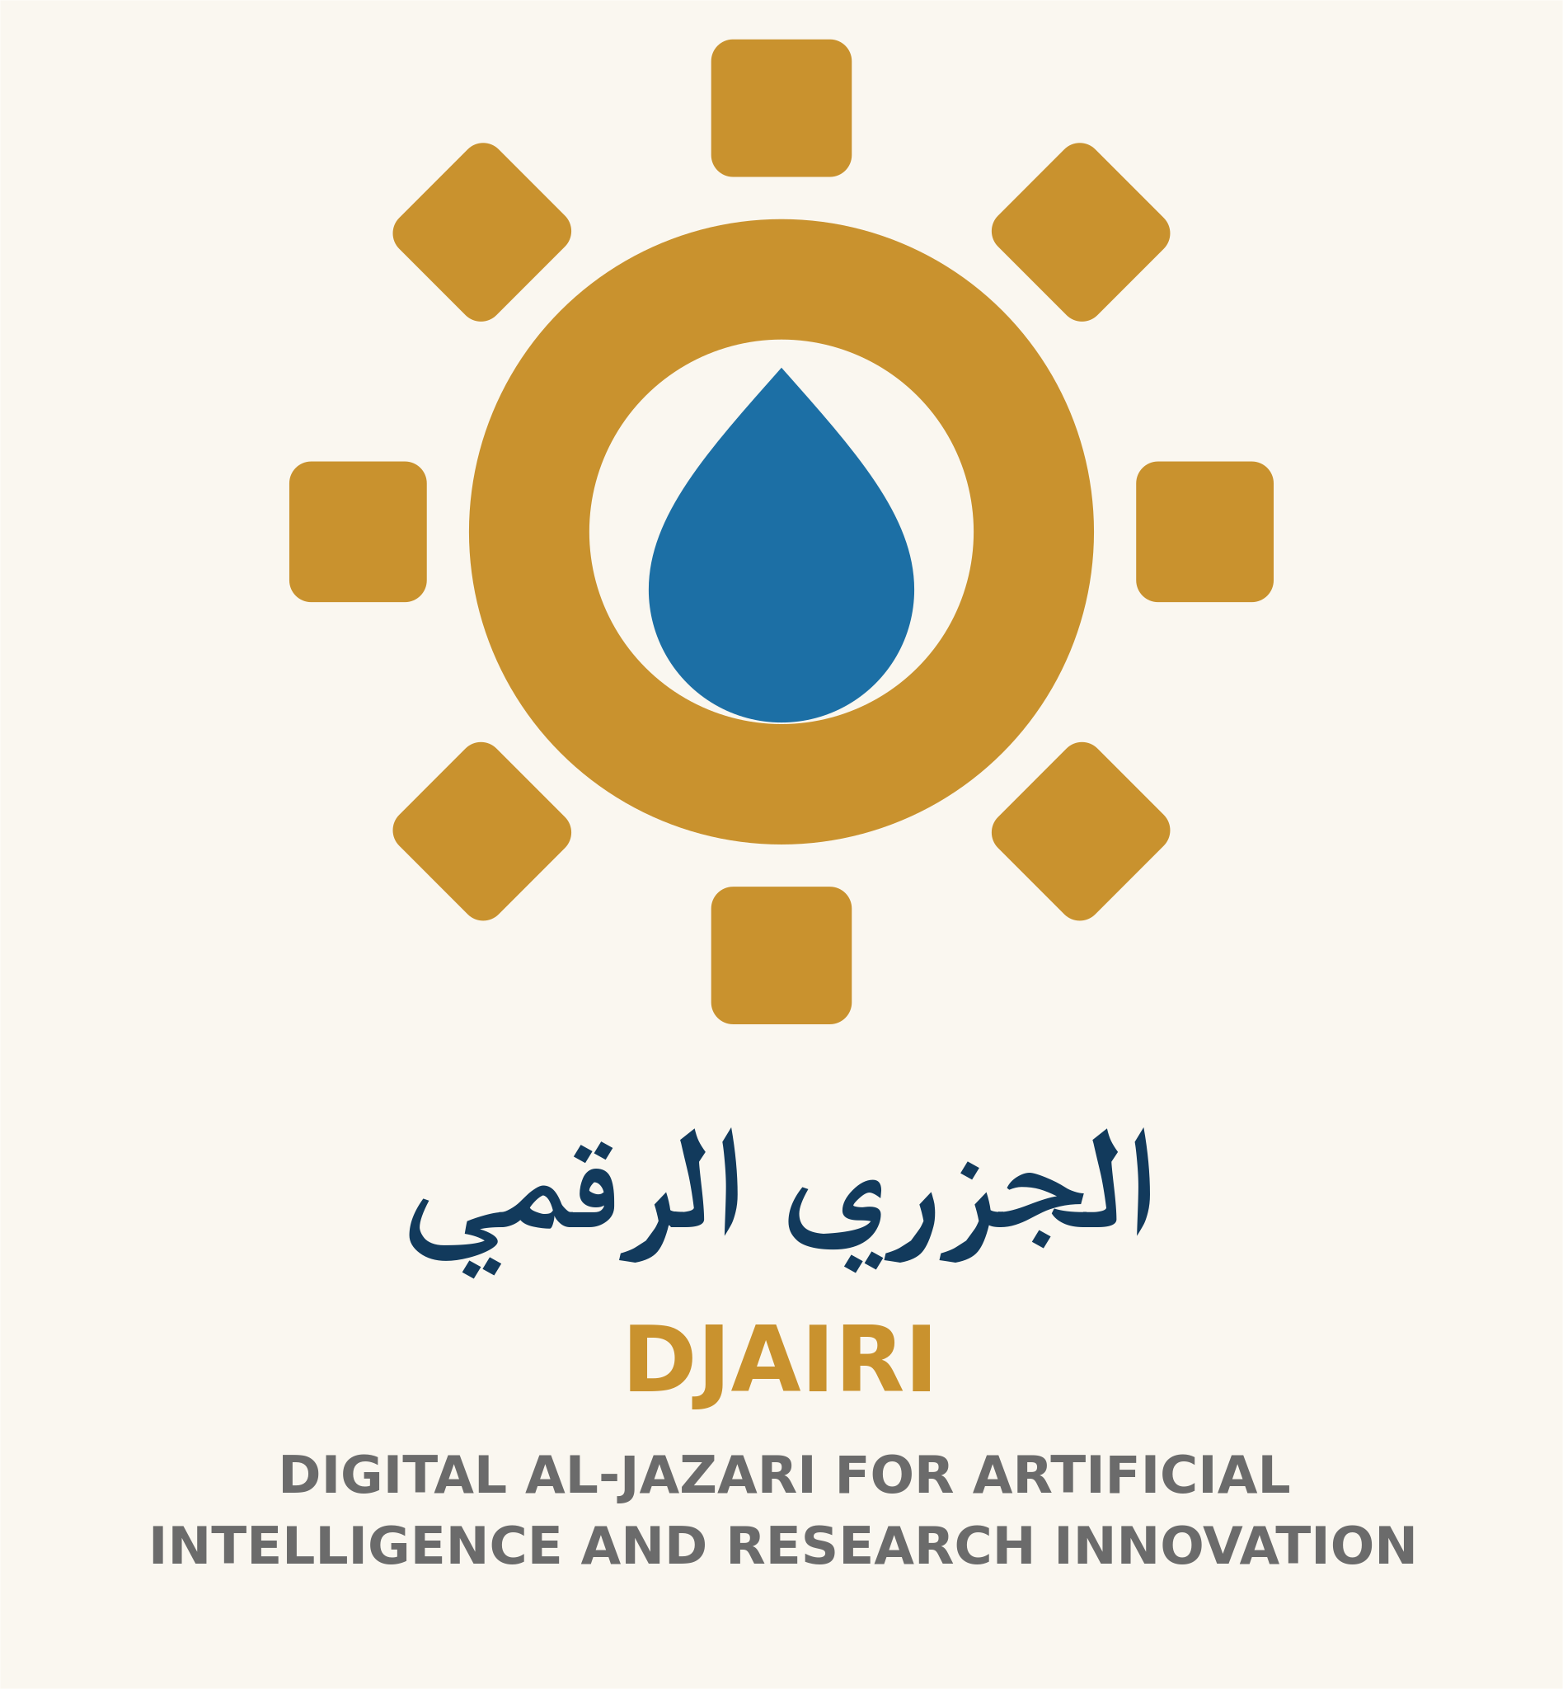

From Idea to Initiative: Plan a Small Community Project
Goal: turn a small idea into a workable, reviewable plan. Suggested time: 30 minutes. AI is optional and may help organize a plan that you then review.
1. Need: What problem have you observed, and for whom? What evidence can you use without revealing personal information? Separate observations from assumptions.
2. Goal: define a small observable outcome, such as producing a clear awareness guide, rather than “solving the community’s problem.” Do not promise untested results.
3. Scope: specify a place, period and estimated participant count. State exclusions. Obtain necessary permissions for the activity or venue before starting.
4. Tasks: write three tasks, an owner, a deadline and resources for each. Review accessibility, safety and privacy concerns.
5. Resources: estimated budget ______; available materials ______; approvals needed ______. This template does not authorize fundraising or a donation campaign.
6. Evaluation: how will you know the activity was completed? Completed resources and a clarity review are useful measures. Views alone do not establish social impact.
Fictional example: a team creates a card about noticing household water leaks and reporting them. Tasks: consult guidance from the responsible authority, draft the card and have an appropriate adult review it. The team does not enter facilities or undertake technical repairs. A general card is the output; impact needs separate evaluation.
Worksheet: Need ______. Evidence ______. Goal ______. Audience ______. Tasks and owners ______. Schedule ______. Resources ______. Permissions ______. Risks and mitigation ______. Completion measure ______. Lessons ______.
Optional prompt: “Organize this general plan into a table. Do not add partners, amounts or results that are not stated. Add questions for missing information.” Check every addition and do not submit community members’ personal details.
Success: the plan defines a need, realistic goal, tasks, resources, responsibilities, permission and a completion measure. Start small and improve; do not present this example as an initiative already implemented by the institution.
Equity lens: who might be excluded by timing or connectivity costs? How can women shape decisions without extra burden? What paper option supports children and beginners? Ask before choosing a tool. Consult our Umm Al-Jimal and Deir Al-Kahf pages without attributing fictional outcomes to them.
Human-Centered AI — DJAIRI. Version 1.1. Educational resource with human review; not field-tested with learners.

